**Lab-1**

**Objective:**

* The objective of this lab is to create database, create table and use of some basic queries.

1. A DB has been created named “BUBT_DB” as follows:

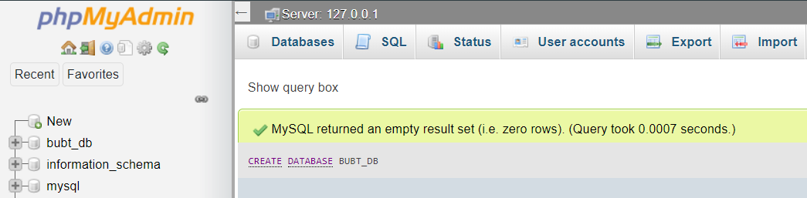

1. Three tables in this DB named “Student”, “Faculty”, “Course” has been created as follows:

**Student Table**

Table creation:

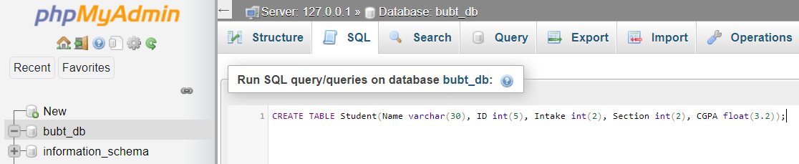

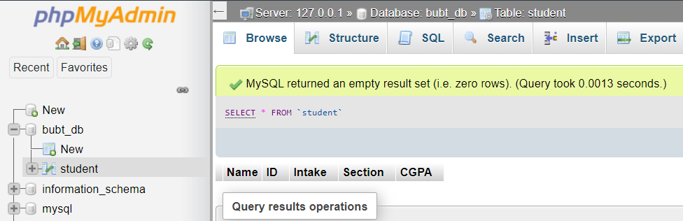

Data insertion:

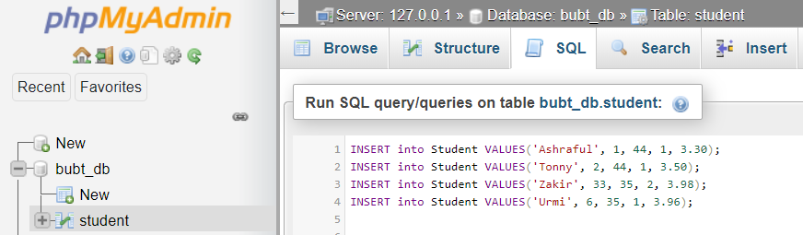

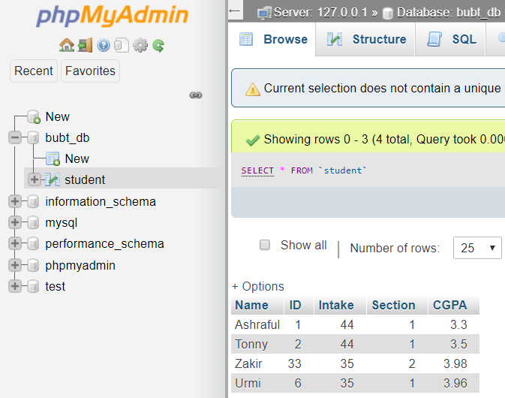

**Faculty Table**

Table creation:

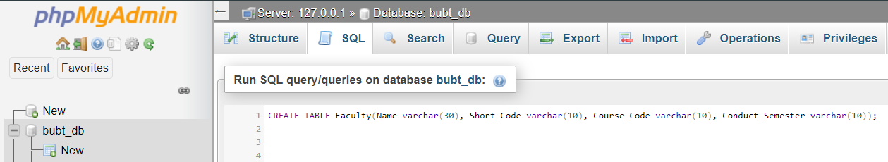

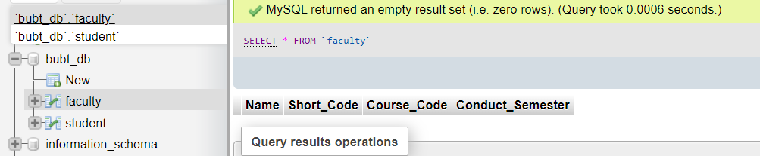

Data insertion:

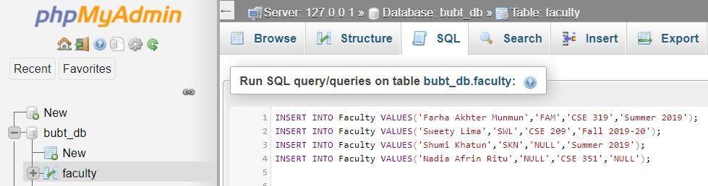

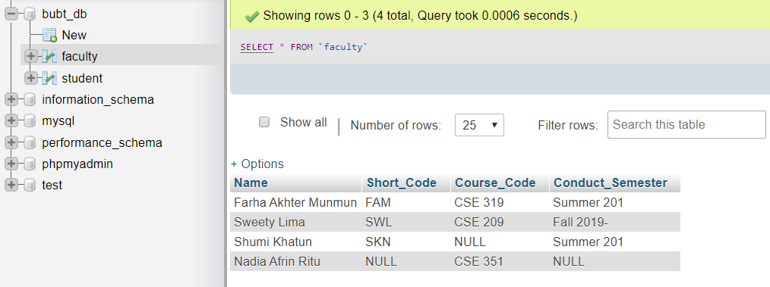

**Course Table**

Table creation:

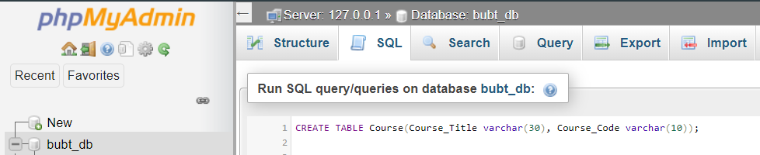

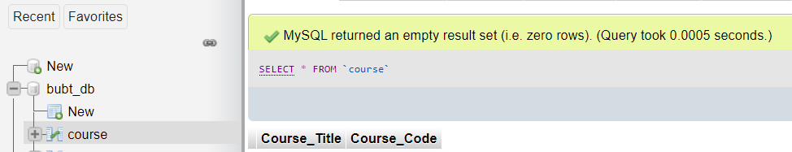

Data insertion:

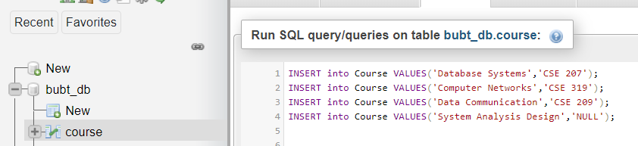

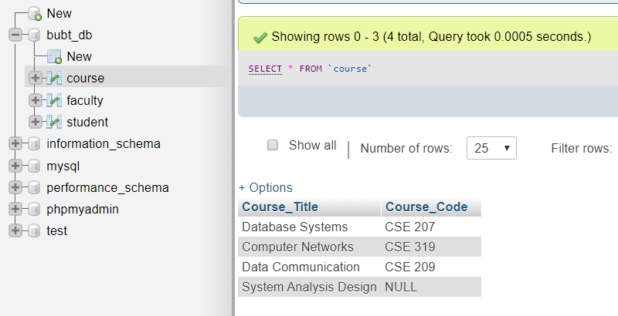

1. a) Updated the short code from **faculty table** whose short code is NULL as follows:

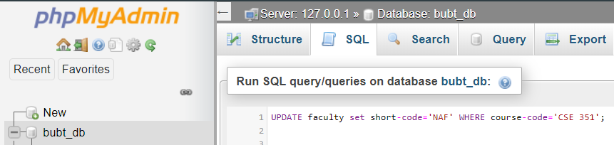

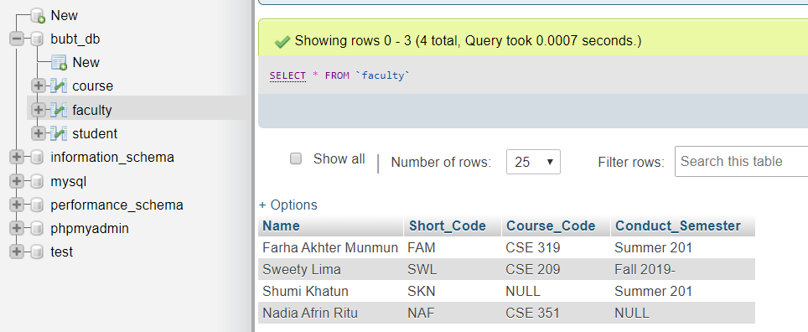

b) Updated the course code that is NULL in “course” Table as follows:

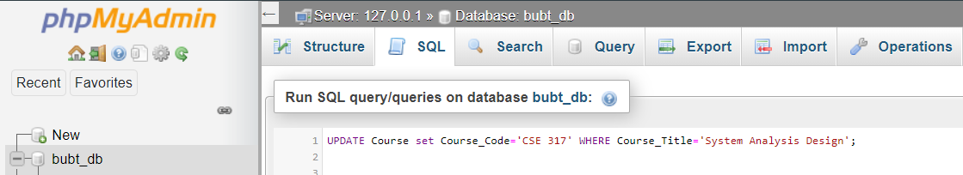

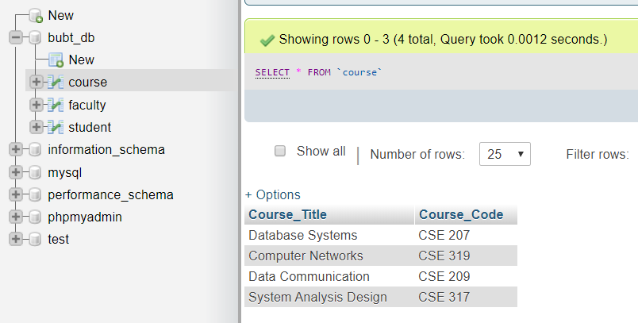

c) Updated the conduct semester that is NULL in “Faculty” Table as follows:

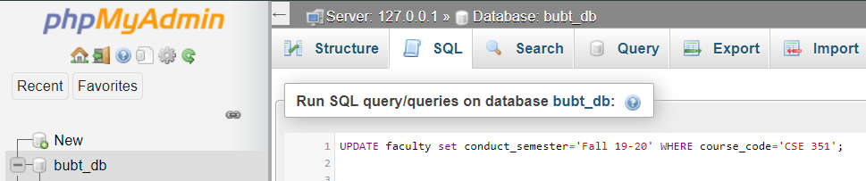

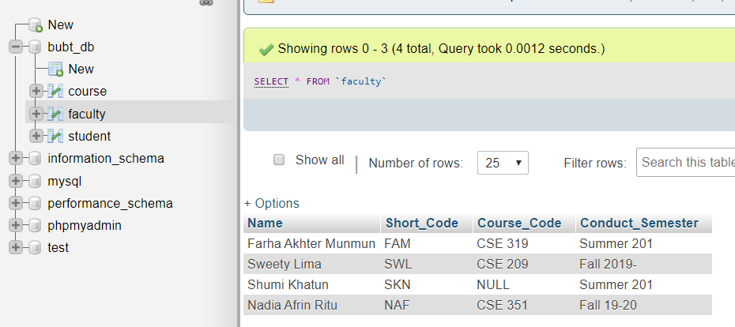

d) A new column has been added named “Age” in student relation as follows:

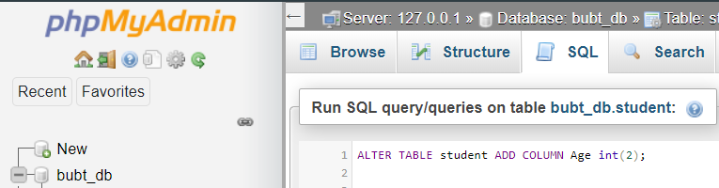

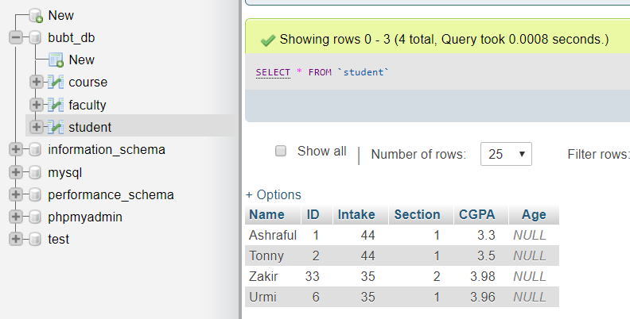

e) Updated the age of each student as follows:

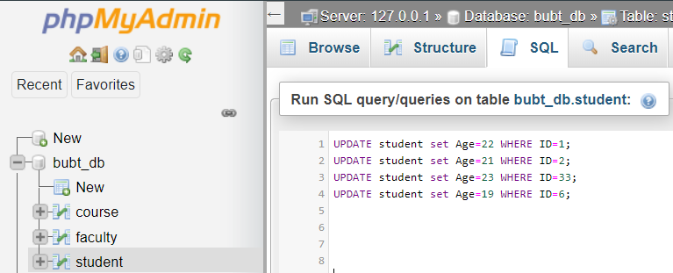

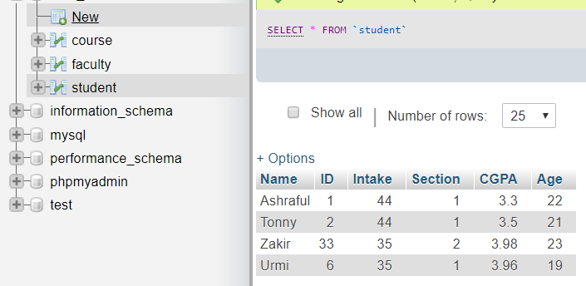

f) Found the names of all Courses in the Course relation as follows:

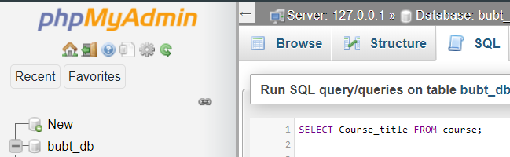

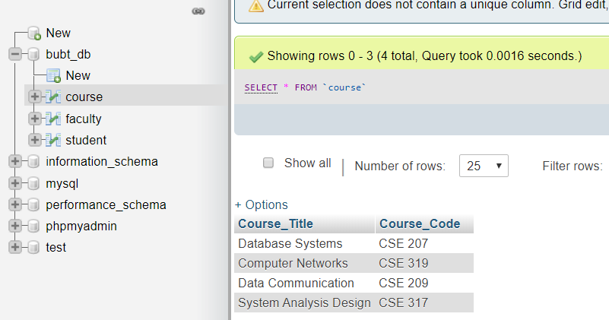

g) Find the names of all teachers who has conducted in summer 2019.



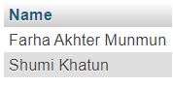

h) Find the names of all students whose CGPA is greater than 3.50.



